Design and Simulation of a 5G Digital Communication System Using Verilog
Dr.Imtiyaz Ahmed B K  Associate Professor  Dept. of SOE, ECE  Presidency University  Bengaluru, Karnataka, India  ay@gmail.com | Viresh Mallikarjun Tarapur  Student  Dept. of SOE, ECE  Presidency University  Bengaluru, Karnataka, India  a@gmail.com | Rethika Sai R  Student  Dept. of SOE, ECE  Presidency University  Bengaluru, Karnataka, India  a@gmail.com
Aneeqha Tarannum SStudent  Dept. of SOE, ECE  Presidency University  Bengaluru, Karnataka, India  a@gmail.com | Sudhanva R Avaghan  Student  Dept. of SOE, ECE  Presidency University  Bengaluru, Karnataka, India  a@gmail.com

Abstract

The high rate of development of wireless communication systems has resulted in the use of modernized digital signal processing methods in the fifth-generation (5G) networks in an attempt to achieve elevated rates of data transfer, reduced latency, and dependability of information transfer. In this paper, a design of a simplified 5G-inspired digital communication system is provided and simulated in Verilog hardware description language. The suggested system represents the key baseband processing blocks of a contemporary wireless transceiver, such as Low-Density Parity-Check (LDPC) encoding and decoding, Quadrature Amplitude Modulation (QAM) and demodulation, Orthogonal Frequency Division Multiplexing (OFDM) modulation and demodulation, and carrier frequency offset (CFO) analysis and correction. Every module is developed separately, and it is combined to a transmitter-receiver chain. The vivado simulation performs functional verification and timing analysis, whereas constellation visualization and CFO correction analysis are done with Python. The findings show that the proposed learning-oriented 5G baseband model is effective, as it has shown that correct signal recovery is achieved, LDPC coding yields better results, and the constellation is better with CFO correction.

Keywords- 5G, OFDM, QAM, LDPC, Verilog, CFO, Digital Communication.

I. Introduction

The growing needs of high-speed data transmission, ultra-low latency, and quality connectivity have been the reasons behind design of 5G wireless communication systems. The current wireless

standards use sophisticated digital baseband modulation methods like QAM modulation, multicarrier transmission using OFDM, and strong

channel coding, like LDPC, in order to better utilize the spectrum and overcome channel impairments. The interaction of these digital blocks is a crucial understanding to the students and engineers of the communications systems and SoC design sectors.

This paper is about the design and simulation of the simplified 5G-inspired design of a digital communication system in Verilog. The plan is not to use the entire 5G physical layer but emulate the major digital baseband blocks around which modern wireless systems are based. Using these modules, it is possible to observe clearly the internal signal flow, timing behavior, and performance trade-offs by implementing and simulating these modules at the register-transfer level (RTL).

The principal findings of the paper are: (i) Verilog implementation of QAM, OFDM and LDPC blocks in a modular way, (ii) creating an end-to-end transmitter-receiver chain, (iii) comparing the performance with and without LDPC coding, and (iv) studying the CFO effects and correction by plotting the constellation.

II. Related Work

A number of studies have been conducted to examine specific aspects of the processing of the 5G baseband, such as LDPC encoding,OFDM modulation, and implementation aspects. The excellent error-correction capability and applicability to parallel hardware architectures have made LDPC codes to be widely used in 5G New Radio (NR). The literature above indicates the existence of efficient designs of both the LDPC encoder and decoder that are optimized towards low-latency and FPGA-implementation.

OFDM is a highly studied multicarrier modulation scheme, on which both 4G and 5G wireless communication systems are based because of its ability to avoid multipath fading as well as the capability to attain excellent spectral efficiency. A number of FFT/IFFT architecture implementations based on FPGAs have been described in the literature to implement the transmission and reception of the OFDM. Nevertheless, the majority of scholarly articles are concerned with single functional units or are based on high-level simulation software like MATLAB. Although they make analysis simpler, these tools frequently obscure much of the important hardware-level behavior of timing, latency and synchronization, which are vital in effective SoC and FPGA-based design of communications systems.

Comparatively, this paper describes a full simplified TX-RX chain written in Verilog that lets one directly see the latency and timing values as well as observe the signal development of all significant baseband blocks.

III. Proposed System Architecture.

The system being proposed represents a simplified pipeline of a digital communication in 5G. At the transmitter, the input data bytes are initially encoded with the help of an LDPC encoder in order to add redundancy to provide error protection. The bits are then coded and converted into QAM symbols with the help of an inverse fast fourier transform (IFFT) and insertion of a cyclic prefix to an OFDM modulator.
To model realistic impairments of wireless systems, the channel adds carrier frequency offset and distortion. The OFDM demodulator is used at the receiver to remove the cyclic prefix and use an FFT to reconstruct frequency-domain symbols. Frequency misalignment is corrected using CFO. Demapping of the recovered QAM bits is then followed by decoding bits by use of an LDPC decoder to reassemble the original data Figure 1 depicts the functional block diagram of the proposed system whereas Figure 2 depicts the system flow.

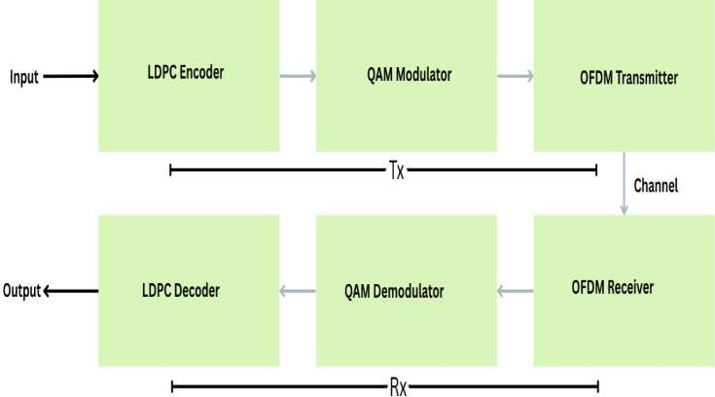

Fig.1. Functional block diagram of the proposed 5G digital communication system.

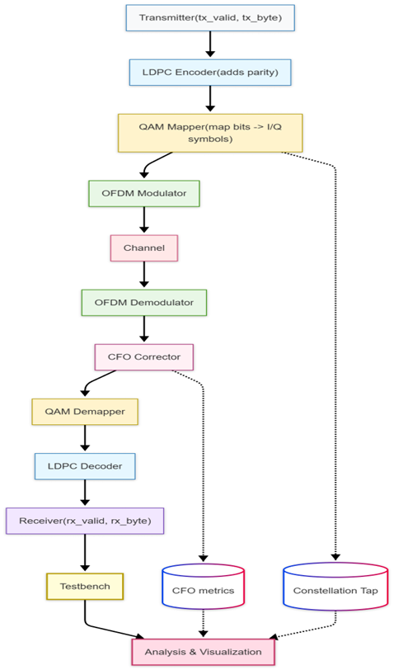

Fig.2.System flow diagram illustrating the transmitter receiver processing flow.
IV. Implementation Details

Modules are all coded in Verilog by a modular approach. All blocks, such as LDPC encoder/decoder, QAM mapper/ demapper, OFDM modulator/demodulator, and CFO handling are tested separately on special testbenches before being integrated.
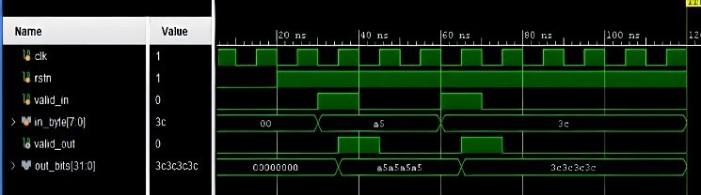

Fig. 3. Simulation waveform of the LDPC encoder module.

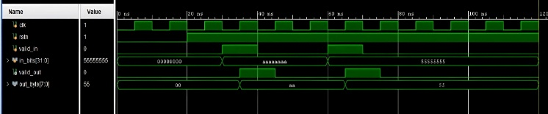

Fig. 4. Simulation waveform of the LDPC decoder module.

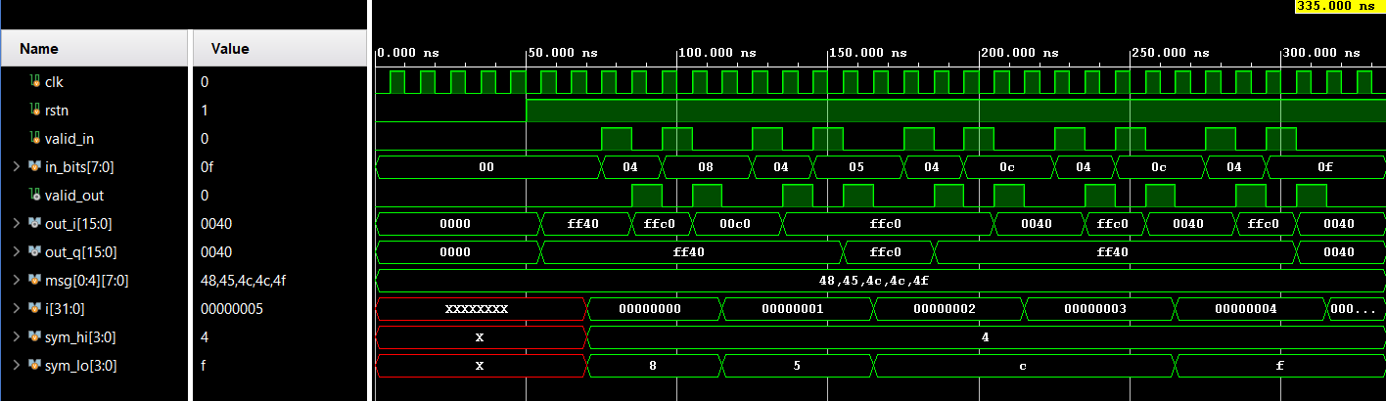

Fig. 5. QAM modulation waveform showing I/Q symbol mapping

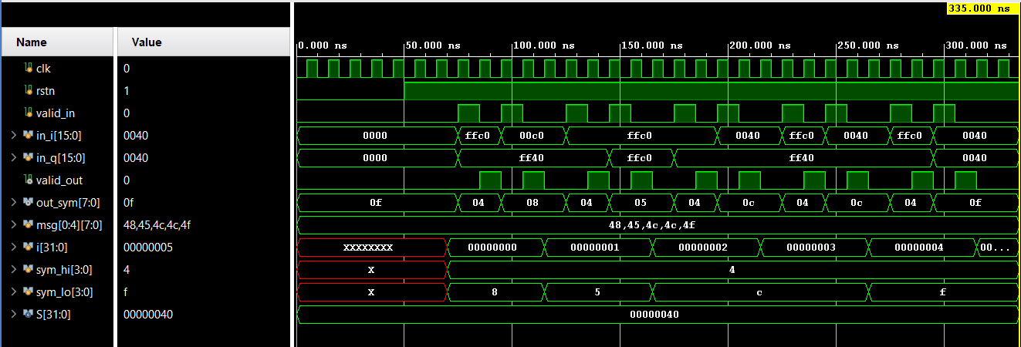

Fig. 6. QAM demodulation waveform illustrating symbol recovery.

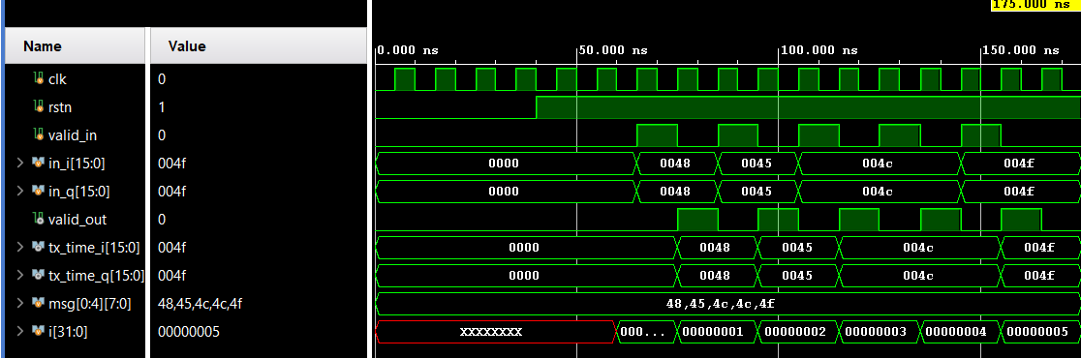

Fig. 7. OFDM modulation waveform using IFFT and cyclic prefix insertion.

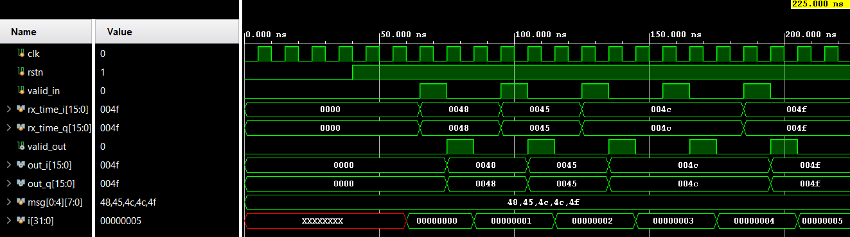

Fig. 8. OFDM demodulation waveform using FFT.

The entire system is modeled in Vivado and gives the ability to check the waveform, analysis of the timing and make the measurement of the latency.

The Python is used to generate constellation plotting and CFO analysis of the I/Q samples of the simulation by exporting I/Q samples. It is a hybrid method that merges the hardware level modeling with signal visualization that is flexible in nature and can reveal a greater detail of the system behavior.

V. Results and Analysis

Outcomes of simulation support the idea of proper end-to-end data transmission by the proposed system. Using LDPC coding, the receiver manages to recover the transmitted information at a lower rate of distortion with a slight latency increase. On the contrary, uncoded system has quicker response but it is more prone to errors.

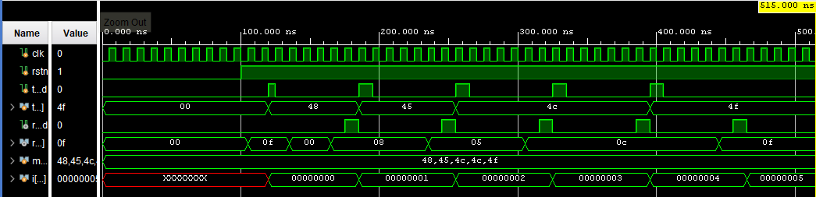

Fig. 9. End-to-end Vivado simulation waveform of the complete TX–RX chain.

Constellation plots are used to illustrate the effects of CFO, indicating the rotation of QAM symbols and dispersion of symbols. Upon correction by CFO, the constellation clusters become much better, and demodulation becomes accurate. Timing and power analysis results of Vivado show that the design is not known to exceed timing constraints and power consumption is low.

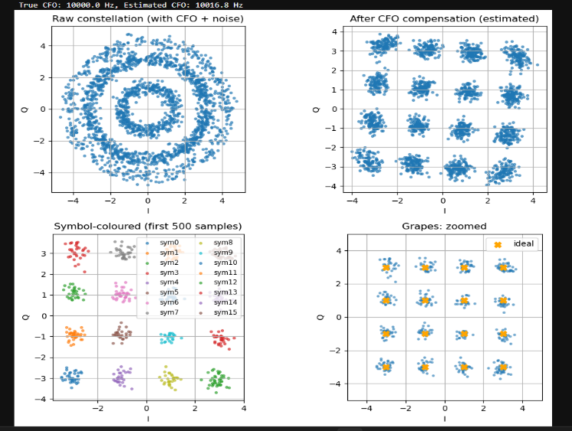
Fig. 10. Constellation plots before and after carrier frequency offset (CFO) correction.

VI. Performance Assessment and Report.

The proposed 5G-inspired digital communication system was tested with large-scale simulation at Vivado and post-processing analysis at Python. Several conditions were tested to know how the system behaves in various settings, such as the behavior of the system with and without LDPC coding, with carrier frequency offset (CFO) and with CFO correction on.

The latency analysis showed that end-to-end transmission was faster with the uncoded system since there was no overhead of encoding and decoding. Nonetheless, such a structure was extremely vulnerable to distortion of symbols and bit errors. With LDPC switching on, the system experienced a slight rise in the latency but the data recovery reliability was enhanced greatly.

(a)
Fig. 11. Performance comparison of the system with LDPC coding and

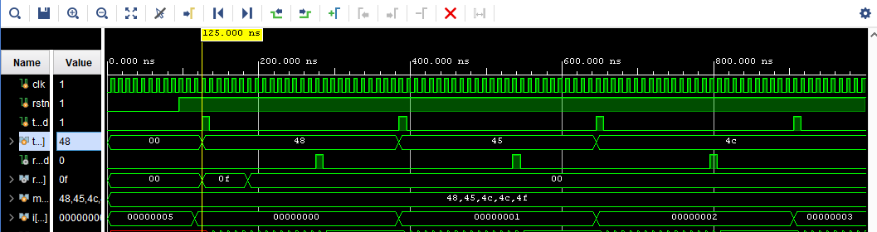
(b)
Fig. 11. Performance comparison of the system without LDPC coding.

This trade-offs between latency and reliability is realistic to consider in the design of a 5G system.

The constellation analysis also showed the strength of the offered system. With CFO, the constellation points were found to spin and diffuse, resulting in the wrong decisions in choosing symbols. The constellation clusters were realigned, and it was possible to demodulate well with CFO correction applied. These experiments confirm the viability of CFO compensation methods within contemporary systems relying on the use of the OFDM.

Vivado synthesis generated power and timing reports showed that the design was able to meet timing constraints at the desired clock frequency and low dynamic power consumption. This proves that the proposed architecture is appropriate in hardware-based learning and scalable baseband design.

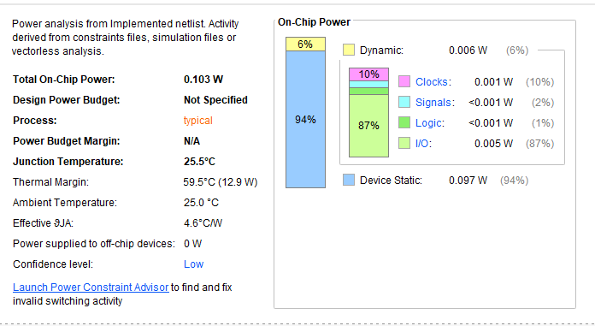
(a)
Fig. 12. Power analysis report

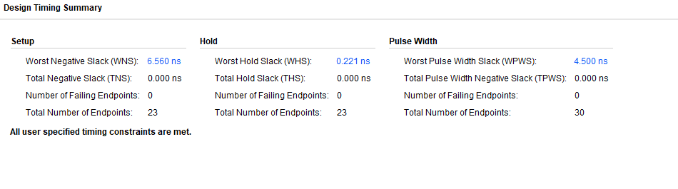
(b)
Fig.12.Timing analysis report generated using Vivado.

VII. Practices and Implications.

The proposed system can be an efficient learning and research platform on how to learn the inner workings of 5G digital communication systems. Verilog modeling of the baseband processing chain enables students and researchers to have practical experience in hardware-based implementation of QAM, OFDM, and LDPC techniques. The modular design further permits the extension or replacement of individual blocks making the system open to experiment with more advanced modulation schemes and coding rates and synchronization methods.

Outside the academic education, the architecture may be modified to prototype next-generation wireless baseband processors. Its RTL approach is useful in development of FPGA and ASIC where timing, latency, and power are major concerns. Python-based analysis also helps in reducing the distance between hardware design and signal processing research.

VIII. Limitations and Future
Enhancement.

Although the suggested model is effective to prove the basic principles of a 5G-inspired digital communication system, it is a simplistic model of a complete physical layer 5G. The additive white Gaussian noise (AWGN), multipath fading and Doppler effects were not completely simulated. The LDPC implementation was also made easier to achieve clarity in preference to complete standard compliance.

Future work entails the use of realistic channel modeling, higher order QAM schemes, and adaptive modulation and coding. Its implementation on FPGA hardware and comparison with real-time measurements would enhance the practical relevance of the system as well. Further development of more sophisticated synchronization and channel estimation procedures is also a potential future activity.

IX. Conclusion

The present paper has provided in detail a design and simulation of a digital communication system based on 5G technology in Verilog. The proposed system offers the understanding of the present-day principles of wireless communication through the introduction of major baseband processing blocks, including LDPC coding, QAM modulation, OFDM transmission, and CFO correction. The correct end-to-end functionality, better reliability with LDPC coding and better signal integrity with CFO correction are proven by the results of simulation. The work illustrates a scaled and educationally useful method of learning and researching about the design of a digital communication system.

X. References

[1] E. Dahlman, S. Parkvall and J. Skold, 5G NR: The Next Generation Wireless Access Technology, 2nd ed. Academic Press, 2020.

[2] T. Richardson and R. Urbanke, Modern Coding Theory. Cambridge, U.K.: Cambridge University Press, 2008.

[3] GPP TS 38.212, Multiplexing and channel coding, NR, 3rd Generation Partnership Project, Release 15, 2019.

[4]OFDM-based Wireless Multimedia Communications. R. van Nee and R. Prasad. Boston, MA, USA: Artech House, 2000.

[5] Y. Li and G. L. Stuber, Orthogonal Frequency Division Multiplexing to wireless communications. New York, NY, USA: Springer, 2006.

[6] J. G. Proakis and M. Salehi, Digital Communications. 5th ed. New York, NY, USA: McGraw-Hill, 2008.

[7] S. Benedetto, E. Biglieri Principles of Digital Transmission: With Wireless Applications. New York, NY, USA: Springer, 1999.

[8] Xilinx Inc., vivado design suite user guide: simulation, ug900, amd-xilinx, 2023.

[9] Xilinx Inc., Vivado Design Suite User Guide: Synthesis, UG901, AMD-Xilinx, 2023.

[10] Wireless Communications A. Goldsmith. Cambridge, U.K.: Cambridge University Press, 2005.

[11] S. Haykin, Communication Systems, 5 th ed. New York, NY, USA: Wiley, 2009.

[12] M. Morelli, C.-C. J. Kuo, and M.-O. Pun, Synchronization techniques for orthogonal frequency division multiple access (OFDMA): A tutorial review, Proc. IEEE, vol. 95, no. 7, pp. 13941427, Jul. 2007.

